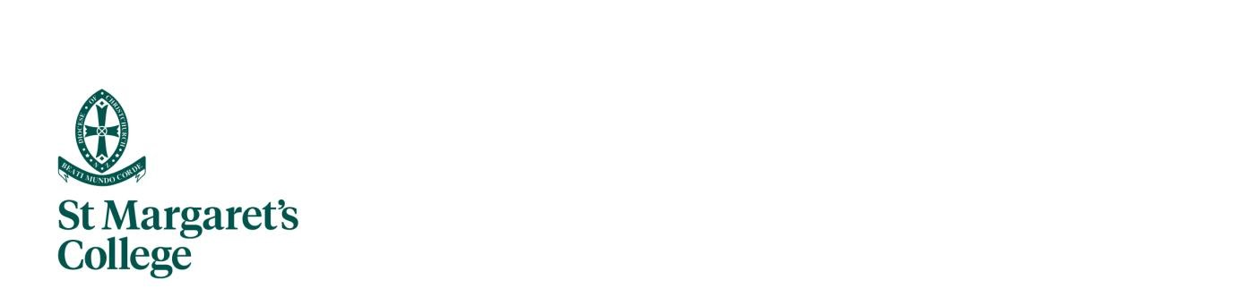

Junior School
Stationery List for 2026

Please note that stationery from last year can be reused

New Entrant
New entrants pack including Junior reading log are supplied by class teacher and charged to your school account.

Year 1
The class teacher will supply the exercise books, and these will be charged to your school account.

Students to purchase for classroom use:
1 Large box of tissues
1 Set of headphones – named (not earbuds)

Year 2
The class teacher will supply the exercise books, and these will be charged to your school account.

Students to purchase for classroom use: (Please ensure all stationery is named)
1 30cm clear plastic ruler (not flexi)
1 Pack of 12 coloured pencils
3 Glue sticks (large)
2 Highlighters
1 Red biro
2 Erasers
1 Set of headphones - named (not earbuds)
1 Large box of tissues
1 Pencil sharpener

Year 3
The class teacher will supply the exercise books, and these will be charged to your school account.

Students to purchase for classroom use: Please ensure all equipment is named (except the whiteboard markers)
2 HB pencils
- Biros (blue and red)
1 Eraser
1 Yellow highlighter
1 30cm clear plastic ruler (not flexi)
1 Set of headphones – named (not earbuds) If buying new with USB (H3040)
1 Pack of 12 coloured pencils
1 Large box of tissues
- Glue sticks (large)
- Whiteboard markers (not named)
1 Black Sharpie fine point marker

Year 4
The class teacher will supply the exercise books, and art supplies and these will be charged to your school account.

Students to purchase for classroom use: (Please ensure all stationery is named)
2 HB pencils
2 Red biros
1 Blue biro
2 Erasers
1 Pack of 4 highlighters
1 20cm clear plastic ruler (not flexi)
1 Set of headphones (named)
1 Pack of 12 coloured pencils and felts
1 Refill .07mm leads (HB)
2 Bic 10k Mechanical Pencil
1 Black Sharpie Permanent Marker Fine Tip
1 Large box of tissues
1 Barrell Pencil Case Pencil Case (to keep on desk) any colour

Year 5
The class teacher will supply the exercise books, and art supplies and these will be charged to your school account.

Students to purchase for classroom use: (Please ensure all stationery is named)
1 Red biro
1 Blue biro
2 HB pencils
1 Black whiteboard marker
1 Black Sharpie Permanent Marker fine tip
1 Eraser
1 20cm clear plastic ruler (not flexi)
1 Packet of 4 highlighters - including green and pink
1 Packet of 12 coloured pencils
1 Pencil sharpener
1 Large box of tissues
1 Set of headphones (named)
2 Glue sticks (large)
1 Pencil Case Barrel (to keep on desk) any colour

Year 6
The class teacher will supply the exercise books, and art supplies and these will be charged to your school account.

Students to purchase for classroom use or re-use from the previous year: (Please ensure all stationery is named)
2 HB pencils
1 Eraser
1 8" Scissors
2 Red biros
2 Blue biros
- 20cm ruler (not flexi) or 15cm ruler
- Glue sticks (large)
- Black whiteboard markers
1 Black Sharpie fine tip
1 Large box of tissues
1 Pencil sharpener
1 Packet of 4 highlighters
1 Packet of 12 coloured pencils
1 Set of headphones (named)
1 Pencil Case Barrel (to keep on desk) any colour

